Note I may interchange the words cutscene or timeline or use one or both at the same time. Same thing.

**Cutscenes**

1. Create a gameobject to hold a “cutscene manager” and a “cutscene holder” script
   1. Cutscene manager – is the script that plays the animations
   2. Cutscene holder is a script that holds the animations that will be played in order
2. Create “*SceneName*CutSceneManager” script
   1. Find any “_____timelineManager” script and copy past everything in the public class onto your new script.
   2. Rename the Animators (and create new ones if there are more characters)
   3. Rename the AnimationClips (and create new ones if there are more characters)
   4. Edit any code that was affected from the renaming. Might need to add lines if you had to add more characters
      1. Example : hart.Play(hartAnims[currentLine].name) becomes manA.Play(manAAnims[currentline].name)
3. Create “*SceneName*Holder” script
   1. Find any “_____CutsceneHolder”/ “_____TimelineHolder” script and copy past everything in the public class onto your new script.
   2. Rename the manager to the corresponding scene you are creating
      1. Example TempleCutsceneManager => TownCutsceneManager if that is how you named item in #2
   3. Rename the AnimationClips (and create new ones if there are more characters)
   4. Edit any code that was affected from the renaming. Might need to add lines if you had to add more characters
4. On the gameobject you’ve created above, add the manager and holder scripts onto it
5. Set the array size and Drag corresponding/fill the animation clips field that will pop up for the **Holder** item
6. Drag/Fill the Animator fields in the **Manager** item
7. Copy past the Black Screen from one of my scenes and put it into your canvas.
8. Drag and put that into “Black Screen” field in the **Manager**. If everything is done correctly the black screen will just overlay everything and you can see much. While working you can disable it by unchecking that gameobject in the inspector 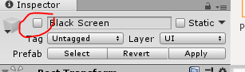  
   Reactivate it before you run the scene so that it will run after the scene ends
9. If you want, you can just copy and paste the Dialogue Manager from my canvas into your canvas too. I plan to separate the name from the text

**Creating Animations**

1. Select the gameobject you want to create an animation for on the Hierarchy panel
2. Find the animation window. Under the play button should be a tiny arrow up and down button. Click on that and create a new clip. Make sure you’re in the animation folder. Name the animation as Gameobjectname_Scene_lineNumber. Example Mariam_Temple_0
3. Set samples to 10, I find that a good sample rate to work with
4. On the Project panel, find the corresponding art folders you need to find the sprites. Drag the sprites into the animation window to the corresponding time.
   1. Time Frame  
      (you will know what time frame you are on marked by the white line)(to change what time frame you want to be on, click on the time frame value you need. You can scrub through it by holding on to it and dragging across the time frame 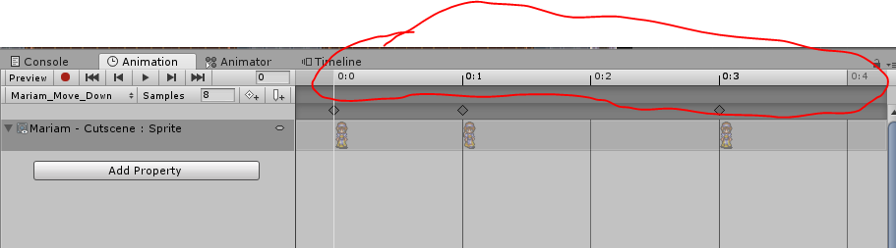
   2. If you need to flip the image, In the animation panel, click the red record button. Make sure you are on the “time frame” you want it to record on” (0:0 or 0:1 or 1:2)
   3. If you need to change the rotation or position of the animation, and it is different from one frame or the other, use the record button.

**Dialogue Manager**

1. Copy and Paste the Dialogue Manager from my canvas into your canvas
2. Make sure the dialogue manager is set up like this  
   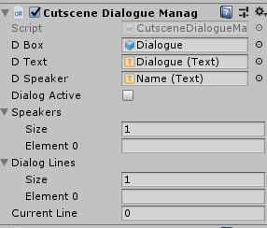  
   crucial to have D Box, D Text and D Speaker filled  
   crucial to have Both Speakers and Dialog Lines to set to size of 1 with empty Element 0  
   crucial to have CurrentLine to 0
3. In the Dialogue Manager, on the inspector, you should see a cutscene holder. Set the Speakers and Dialogue Lines to the same size. Fill them with the corresponding items. Speakers is just the text that will say who is speaking and then Dialogue lines is their dialogue lines. (This is a new addition compared to what I showed you on 10/23 in the group meeting)

Notes:

-Use prefab characters of towns people so that the sprites will just follow the person when you move them.

-If you don’t want the sprites to be there because they’re asleep, in the animation panel, click on “Add Property” then find the Sprite>Setactive and click the plus sign next to it. This will then add the property on to the animator and you can uncheck it to make it disabled.